Create max-temp.txt file and load to Hadoop. Then change the access mode of group and user.

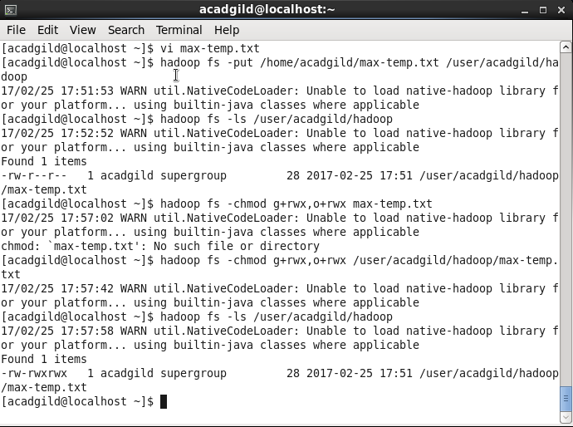

The created max_temp.txt file.

